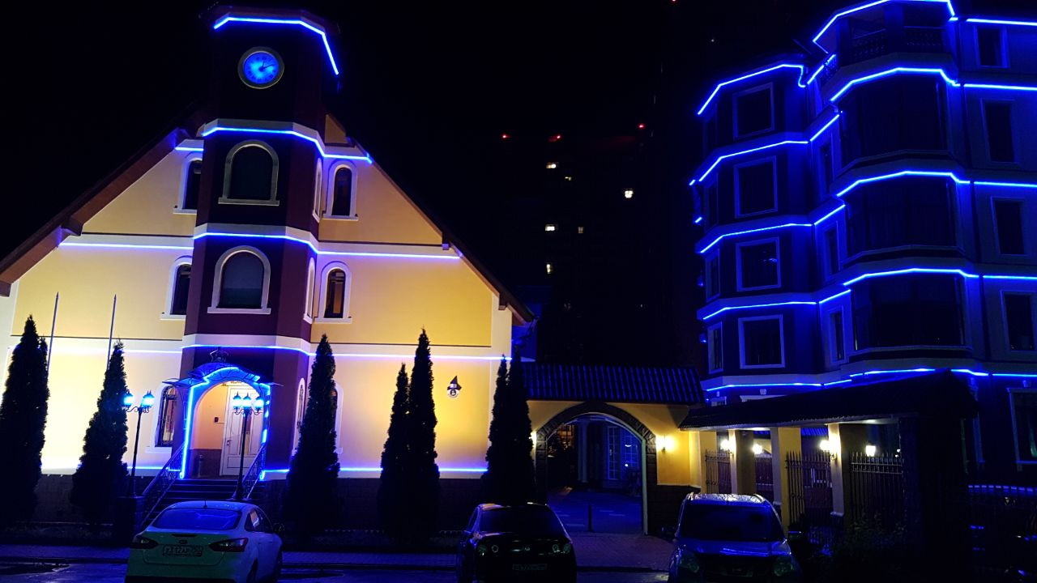
A V S H A R - C L U B
POLICY QUALITY, FOOD SAFETY
HOTEL AND ENVIRONMENT
Avshar Club

Avshar Club, together with all the staff, protecting nature and the environment, has the necessary determination to provide the highest quality services.

Within the framework of the overall quality assurance, we maintain, develop and constantly increase the effectiveness of the dynamic structure of the quality management system.

With a view to sustainable development and environmental protection, we comply with all laws, regulations and environmental protection regulations and comply with all requirements stipulated by law.

Through its work, we determine its impact on the environment, control the negative impacts and possible waste and their possible danger. To take all necessary measures to reduce air pollution, water and soil, minimization of energy and natural sources of expenditure. We constantly monitor and improve the technology of their activities.

To achieve success in protecting the environment are conducted to inform staff and give them personal responsibility.

Informative work associated with the knowledge of the environment values ​​are held not only among the staff, but also the guests and authorities. Contribute to the development for environmental projects in conjunction with various non-governmental organizations.

In order to ensure the health and safety of guests, implemented safety control of food products, carried out all the hygiene requirements are complied with various national and international laws and requirements, satisfying demands and expectations of customers, constantly improved activity.

Our hotels and competing successfully in domestic and international markets in the framework of these principles, resolute to continuously ensure the leading position.
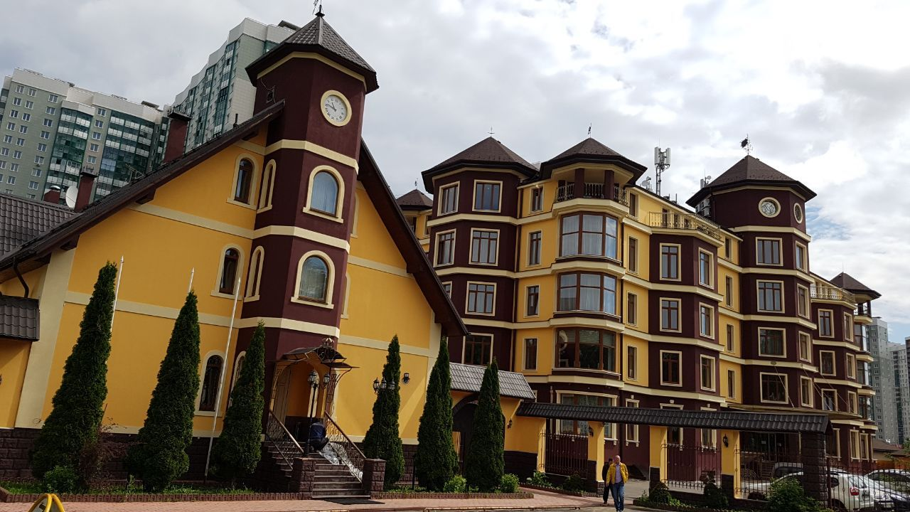
Avshar Club

BASIC INFORMATION:

Officiаl Rating: 4 stars
Address: Moscow region,
Krasnogorsk, md. Opaliha,
Str. Novo-Nikolskaya, h. 2 b

Total area: 6 000 m2
Phone: 7 (929) 999 33 88
7 (926) 999 33 88 Fax: 0090 242 715 May 25 El. Page: www.avshar-club.com
E. mail: avsharhotel@gmail.com
avshar-event@yandex.com
Number of rooms: 30 rooms
Max.occupancy: 70 persons.
Distance from Vnukovo Airport: 40 km
Distance from Crocus Expo: 10km
Distance from Sheremetyevo airport: 30 km
Distance from Golf Club Nakhabino: 3 km

*** In order to maintain a high level of service, please bring to the attention of guests and specify the directories that establishments located in the fresh air at the transition between summer and winter operating concepts on the actual weather.

*** The hotel accommodation with animals is prohibited.
Arrival and departure of guests:
• Welcome guests with champagne and flowers in the room. On the day of arrival, fruits served in the room.
• Provision of umbrellas in the rain
• Free provision of baby carriages (on availability).
• When leaving the hotel with your own car available water and wet wipes.
• In case of late check-out the possibility of providing accommodation for late check-out (according to availability).

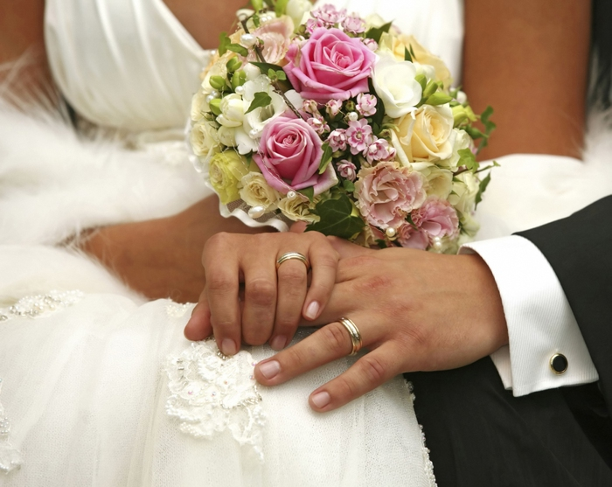
Avshar Club

Special free concept for honeymooners and wedding anniversary:

Services Newlyweds Wedding Anniversary
The room upon arrival wine, snacks and fruit
Possibility of in-room breakfast the first morning
Special bed linen
Scented candles in the room
Meeting upon arrival with flowers
Fresh flowers in the room
Cake in the form of heart on two people
Free access to the Fitness Avshar

Room service:
Room service is carried out from 8:00 to 24:00 daily menu, which in addition to food includes cold and hot beverages. Alcoholic drinks are served in your room for an additional fee

Mini bar:
Replenished daily from 09:30 to 16:00
Filling: 2 Coke, 2 bottles of water, 2 mineral water, 2 dietcolas, 2 Sprite, Fanta 2, 2 beers. The Luxe rooms and VIP Presidential stocked mini bar complemented by a mini-alcoholic beverages.
Tea & coffee set refilled daily from 09:30 to 16:00 hours.
The room for children from 0 to 2 years:
Cots and pillow, baby bedding, blankets, bedspreads, pot, baby bath with a hammock for swimming, set on the baby care products (shampoo, cream, cleansers, wipes, soap, plaster)

Guest Accommodation

• housekeeping service for late check-out.
• Extensive range of accessories in the room for regular guests.
• Carrying out cleaning rooms - daily, bed linen is changed every other day (when the individual requests linen changed every day)
• The provision of extra beds in a room
• Complimentary toiletries, disposable terry slippers and bathrobes with the label.

Avshar Club

Room Type | Room Rate
 | Single |  | Double
Standard | 4900 r. | 5900 r.
Comfort | 5500 r. | 6500 r.
Deluxe | 7500 r. | 8500 r.
Luxe | 15000 r.
Family room | 8000 r.
Honeymoon room | 15000 r.
VIP Luxe | 21 000 r.
Presidential suite | 30 000 r.

We are ready to give a discount of 15-20% on all room categories!!!
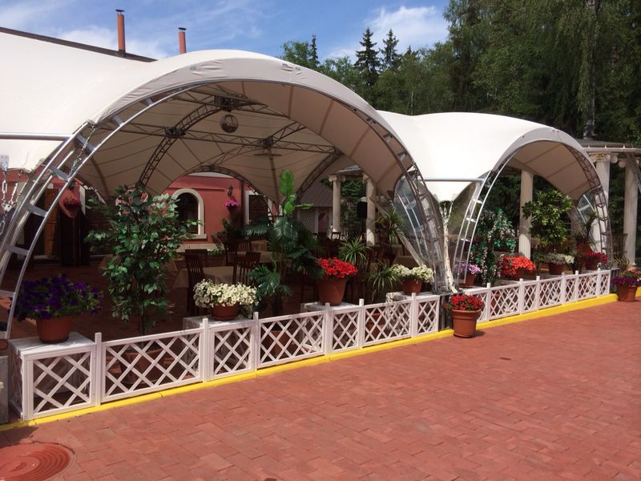
Restaurant & Sports «Avshar Club Bar"

The hotel has a restaurant Avshar Club c lovely garden, large banquet rooms, summer terrace, winter and summer houses.
Kitchen:
European, Caucasian and Russian.
All bars and restaurant beverage service performed by waiters at the table.
- In all bars and restaurant spirits, local and international alcoholic drinks are served in glasses, service of alcoholic beverages is not carried out in bottles.
- Persons under 18 years of service of alcoholic beverages is not provided.
- At breakfast hot drinks are served at the table.
-At breakfast, lunch and dinner are served freshly squeezed orange juice.
- Preparation of individual power in the presence of features in nutrition in children, allergies to certain food ingredients, diet, etc.

Hours Food Menu

07:00 - 10:00 Breakfast Standard
08:00 - 11:00 Breakfast Standard
10:00 - 11:00 Brunch Standard
12:30 - 14:30 Lunch On the menu
12:00 - 16:00 Lunch Snack / Snacks
19:00 - 21:30 Dinner Menu
20:00 - 23:30 Hookah
19: 00 - 24:00 Karaoke
12: 00-24: 00 Billiards
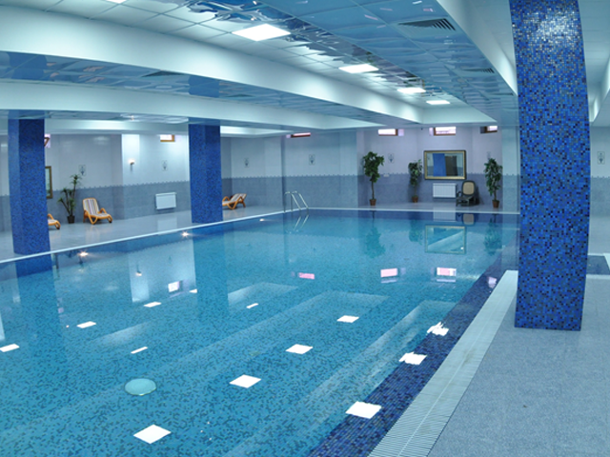
Avshar Fitness

Avshar Fitness, offers a combination of luxury with global trends of wellness services. This is the place where your body and soul will enjoy the harmony, where all the gifts of nature in the form of environmentally friendly products to help realize your wishes. And do not forget that all of your whims will not bring harm to the environment. Use 100% natural cosmetics. In addition, wishing to continue the spa home can buy everything you need in SPA shop.

08:00 – 23:00 | Indoor pool | Fitness Centre
08:00 – 23:00 | Steam room | Hamam | Sauna
Services:
Free services: Swimming pool
Sauna
Steam
Traditional Turkish Hamam
Relaxation Room
Fitness centre
Paid services : Eastern massages
Soothing and relaxing massages
Traditional peeling and foam massage in the hammam is spent on natural basis
WORLD OF SPORTS AND ENTERTAINMENT

Day games: Zumba, Badminton, Table Tennis, Gymnastics
Callanetics, Pilates / Aerobics

Pool Games: Water Polo, Volleyball,Water Gymnastics

